LAB 8: List
Part A: List
List and String Check
- Generate the output from the following program:
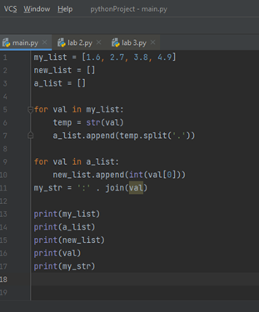

Mutable List
- List is mutable, write a program to generate the given output.
Output sample:
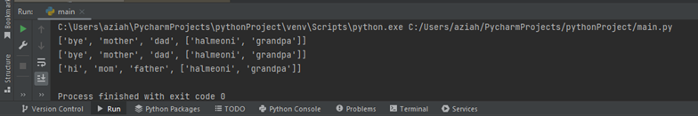

- Given numList = [1,3,5,5,2]. Write a program that:
  - Sorts the list.
  - Adds 4
  - Remove on duplicate
  - Inserts 6
  - Print the number of items in the list.
Part B: Test yourself!
- Write a Python code to create a list number using these number = 65, 75, 85, 95, 105 and check number that prompt the user to enter a number to check that number is available or not in list.
The program should work as follows:
  - The entered numbers should be stored in a list named “validNumbers” that contains only the numbers between 0 and 100. Check for the wrong input, where the numbers should not be less than 0 or more than 100.
  - The program should then determine:
    - Sum all the items in the list
    - Average of the items in the list
    - Multiply all the items in the list
  - To create the list, the user can use these number [65, 75, 85, 95, 105]
- Write a Python program to shuffle and print a specified list.
food = [“cookies”, “brownies”, “cake”, “ice cream”, “chocolate”]
- Write a Python program to get the difference between the two lists.
- Write a Python program to convert a list of characters into a string.

